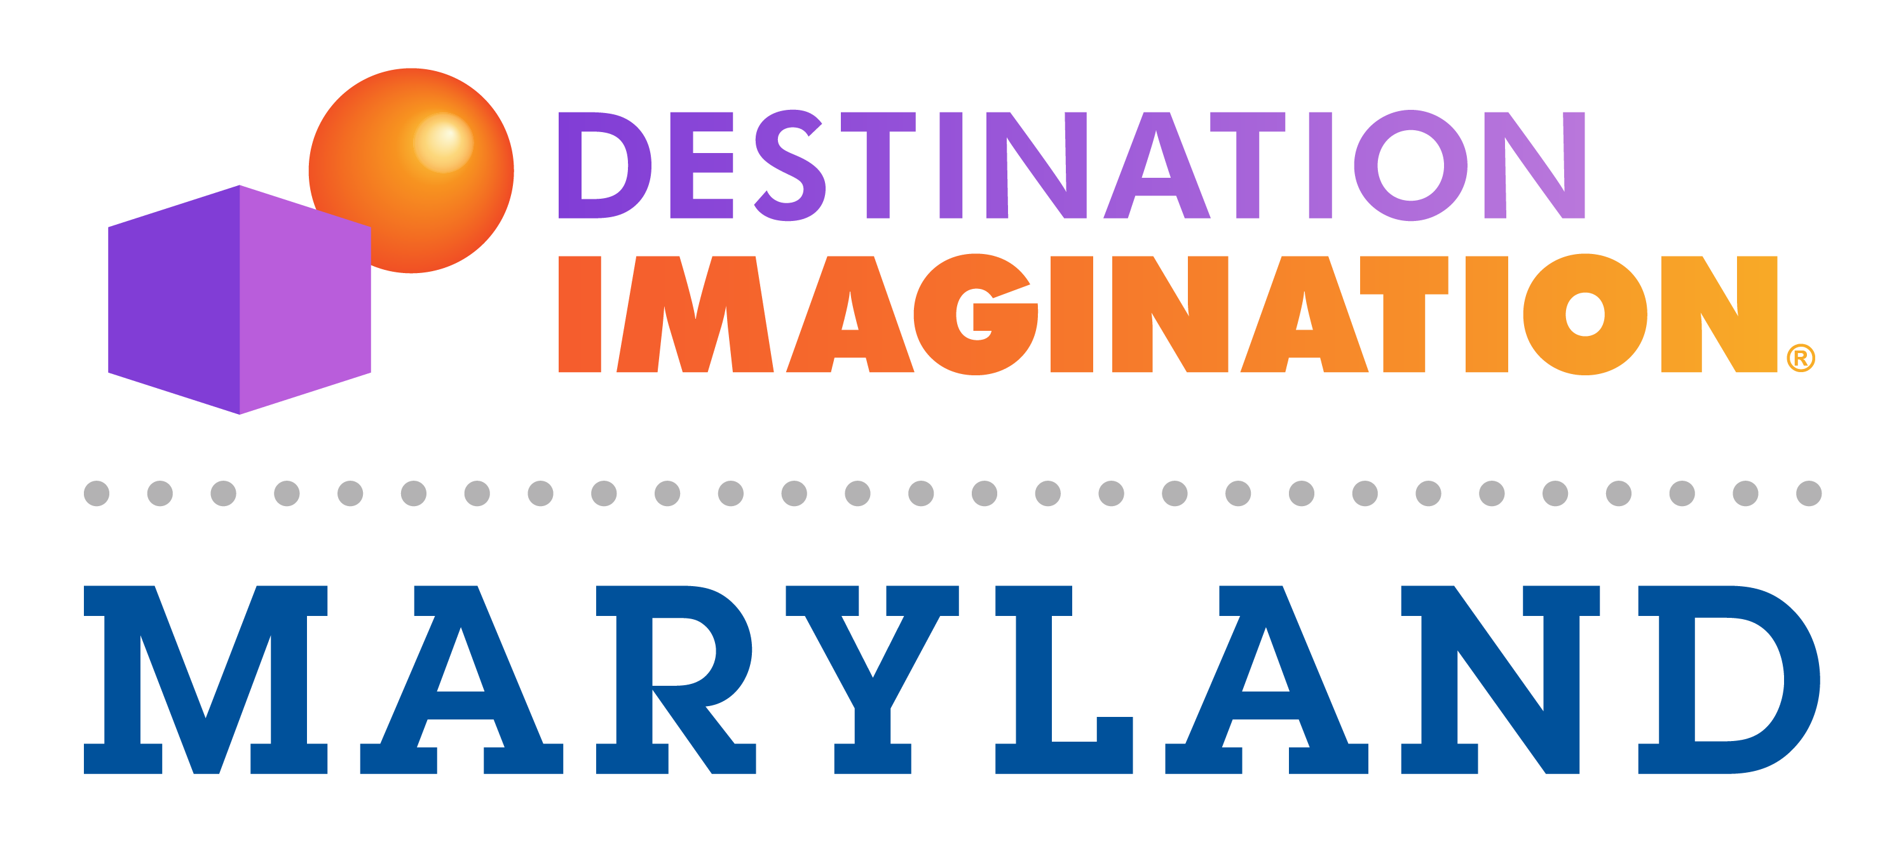
Tools for Success
In school . . . and life

In Destination Imagination® (DI) student teams collaborate to learn 21st Century Skills through challenges that foster creative and critical thinking.

DI: an educational program where student teams independently solve open-ended Challenges and present their solutions at tournaments. In working to solve our Challenges, our teams learn important life skills including time management, presentation skills, collaboration, conflict resolution, and creative and critical thinking.

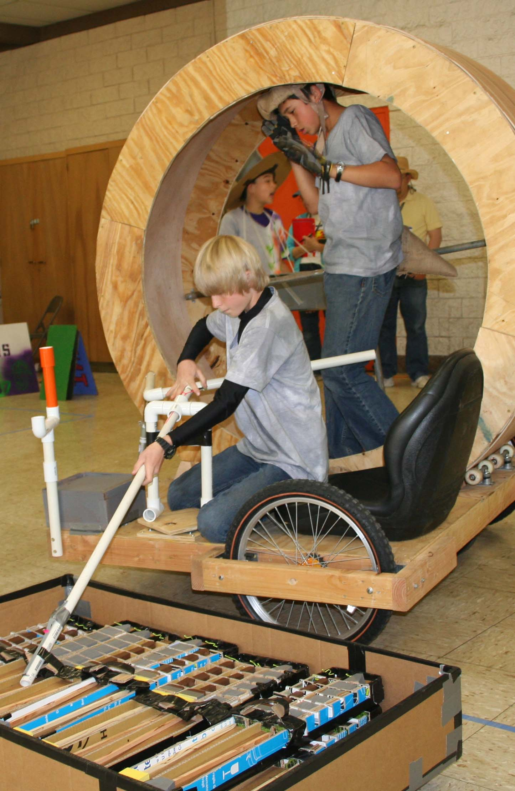
Who: Students from grades K-12 participate, with up to seven members per team. Each team needs an adult Team Manager who helps students stay on track but does not directly help the team develop their solution to the DI Challenge. Team Managers can be faculty members, parents or other volunteers.
What: There are six new DI Challenges to choose from each year which are developed by a team of educators and industry experts with emphasis on 21st Century Learning Skills, STEM, Common Core and the Arts. The areas of focus include: Technical, Scientific, Fine Arts, Improvisational, Structural and Service Learning. There is also a non-competitive Early Learning Challenge that allows kids to build social and problem solving skills.
When: Each season takes place from September through May. Teams typically spend 4 to 6 months developing and practicing their Challenge solutions.
Where: Tournaments typically take place in local schools. And, while most schools run DI as an after school program, some school districts incorporate the program into their electives curriculum.
Why: Teams in our program improve in creative thinking, critical thinking, and collaborative problem solving. Our kids experience the creative process, develop new friendships, and they learn to work together.
Destination Imagination Teaches:

21st Century Learning Skills:
- Creativity and Innovation
- Critical Thinking and Problem Solving
- Communication
- Collaboration
For more information:
www.destinationimagination.org
www.marylanddi.org
STEM
- Science
- Technology
- Engineering Design
- Mathematics
ARTS
- Theater Arts
- Fine Arts
- Writing
- Musical Performance & Composition

